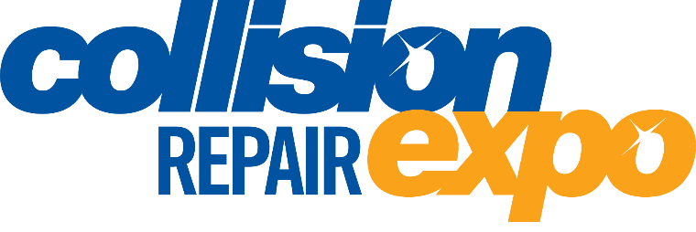
29 April – 01 May 2021
MELBOURNE CONVENTION & EXHIBITION CENTRE

The Collision Repair Expo is the nation’s most comprehensive exhibition of body finishing materials, crash repair equipment and tools. Returning to Melbourne in 2021, industry experts will update businesses on the latest technologies available and off free seminars.
More than 50 top Australian and international brands will be on display at the Expo. Exhibitor equipment and product demonstrations will be a highlight, including the return of Lowbake with their popular onsite spray booth featuring regular live and interactive demonstrations from the major refinish suppliers.
The Collision Repair Expo will be co-located with the Australian Auto Aftermarket Expo. Entry is free and visitors will be able to check out a combined total of about 400 exhibits over nearly five acres of display space.

Register to visit now at www.collisionrepair.com.au

